****Животные

3

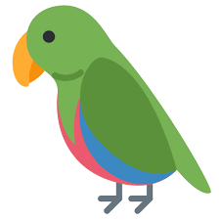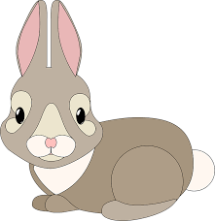**волк**

7

6

2

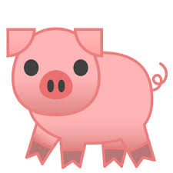**кот**

|  |  |  |  |  |  |  |  |  |  |
| --- | --- | --- | --- | --- | --- | --- | --- | --- | --- |
| 1 |  |  |  |  |  |  |  | 11 |  |
| 2 |  |  |  |  |  |  |  |  |  |
| 3 |  |  |  |  |  |  |  |  |  |
| 4 |  |  |  |  |  |  |  |  |  |
| 5 |  |  |  |  |  |  |  |  |  |
| 6 |  |  |  |  |  |  |  |  |  |
| 7 |  |  |  |  |  |  |  |  |  |
| 8 |  |  |  |  |  |  |  |  |  |
| 9 |  |  |  |  |  |  |  |  |  |
| 10 |  |  |  |  |  |  |  |  |  |
| 11 |  |  |  |  |  |  |  |  |  |
| 12 |  |  |  |  |  |  |  |  |  |
| 13 |  |  |  |  |  |  |  |  |  |
| 14 |  |  |  |  |  |  |  |  |  |
| 15 |  |  |  |  |  |  |  |  |  |

**собака**

**коза**

**кролик**

**черепаха**

**канарейка свинья**

**хомяк**

**корова**

5

**попугай 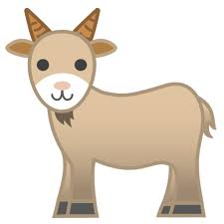мышка**

**обезьяна**

**овца**

**лошадь**

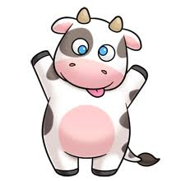

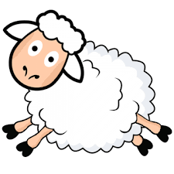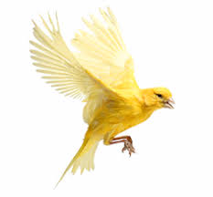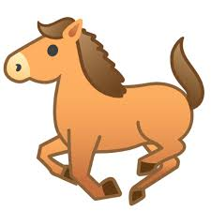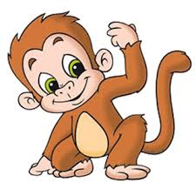

10

15

14

13

12

9

8

4

1